**Custom Sprite Sheet Creation Using Photoshop**

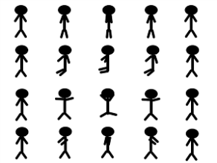

This sprite sheet is designed to perform stickman four operations includeing waliking, sit, jump and dance respectively.

* **Walk:** Stickman will perform walking action with texture co-ordinate y = 0.75 and x value varies from 0 to 1 incrementing by 0.2 ( 1 / 5 ).
* **Sit:** Stickman will perform sitting action with texture co-ordinate y = 0.5 and x value varies from 0 to 1 incrementing by 0.2 ( 1 / 5 ).
* **JUMP:** Stickman will perform sitting action with texture co-ordinate y = 0.25 and x value varies from 0 to 1 incrementing by 0.2 ( 1 / 5 ).
* **Dance:** Stickman will perform sitting action with texture co-ordinate y = 0 and x value varies from 0 to 1 incrementing by 0.2 ( 1 / 5 ).